Name: Ali Albayrak

Student Id: P304320

Portfolio 6

1.Demonstrate how to develop a client/server application with sockets in Java. Provide a sample code snippet or an executable application (e.g. two-way messaging program over network) for demonstration.

To demonstrate; I created a two-way messaging program over local network. Server side:

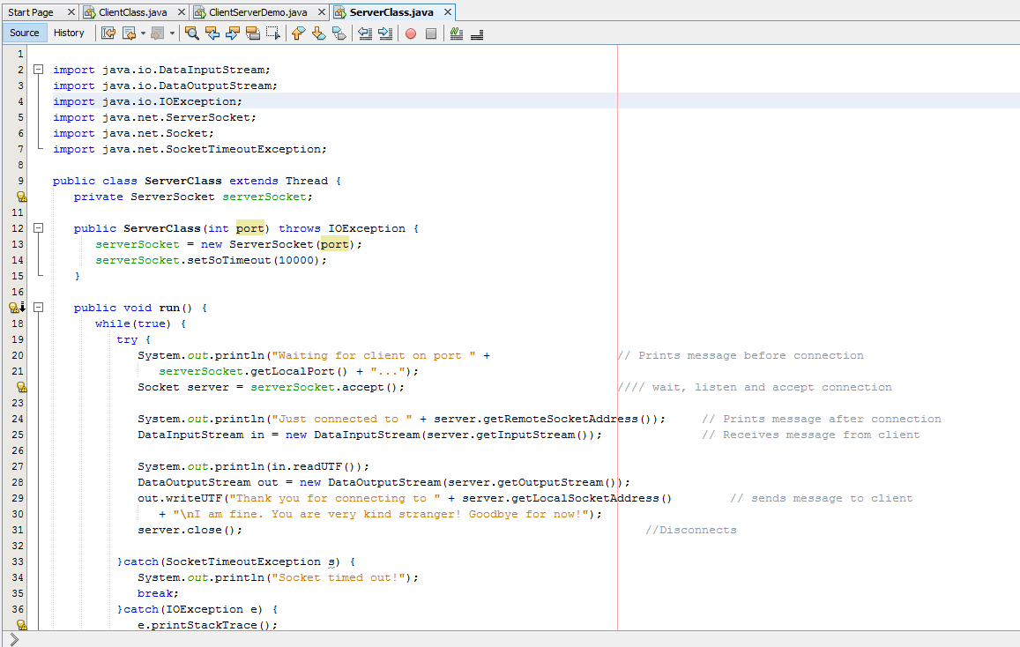

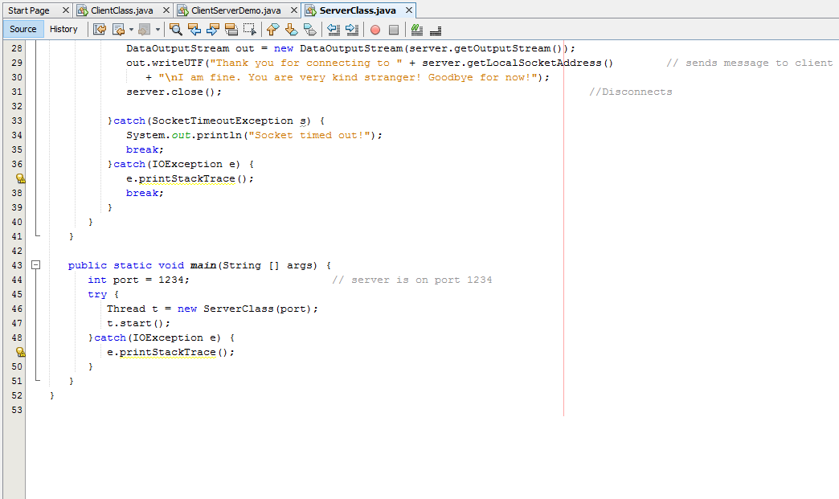

Client Side:

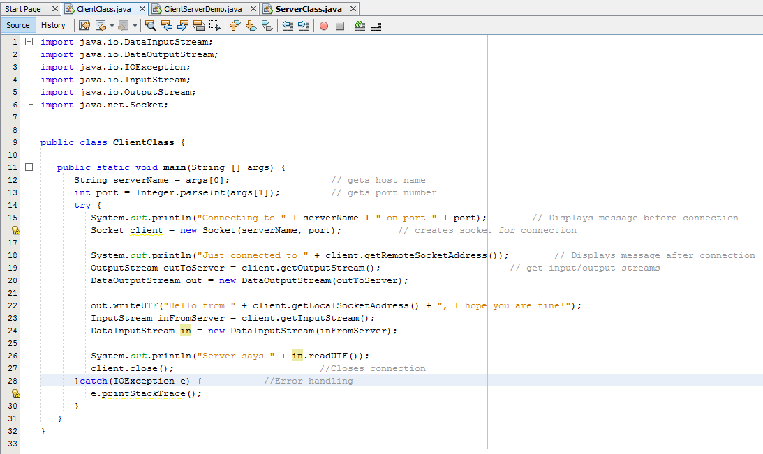

When we run these classes from cmd.exe, Output is like following;

Server Side:

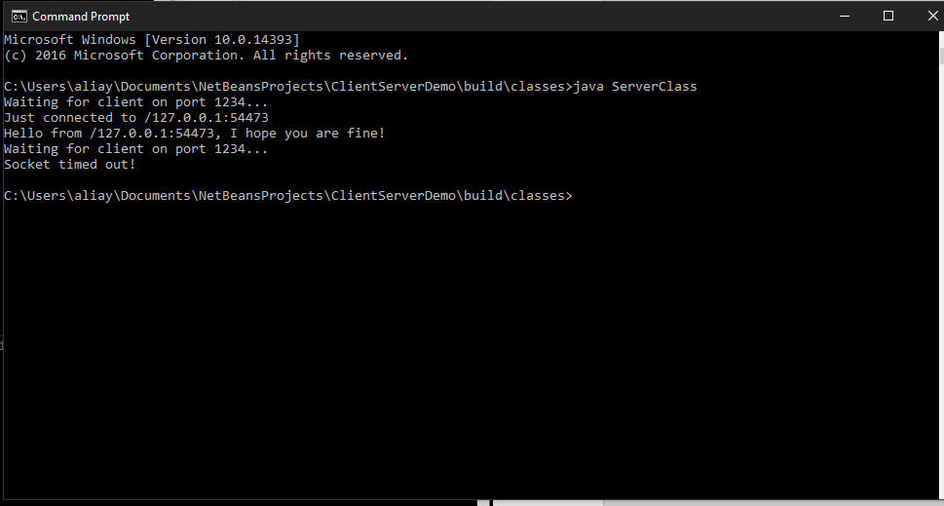

Client Side:

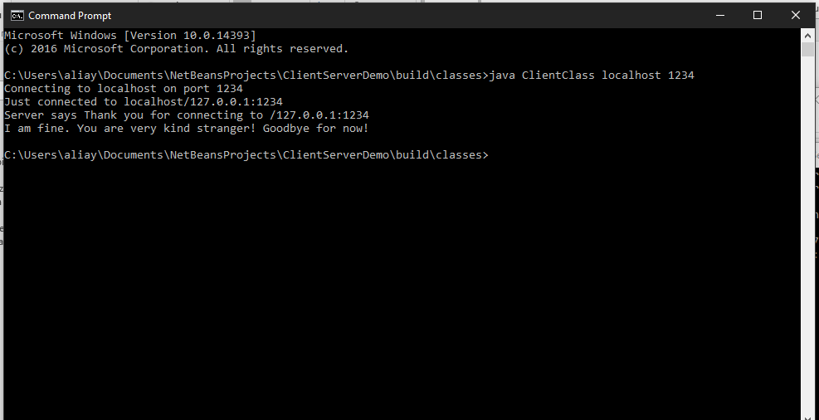

2. Demonstrate how to develop a Java application that uses RMI (Remote Method Invocation). Provide a sample code snippet or an executable application for demonstration.

Server Side:

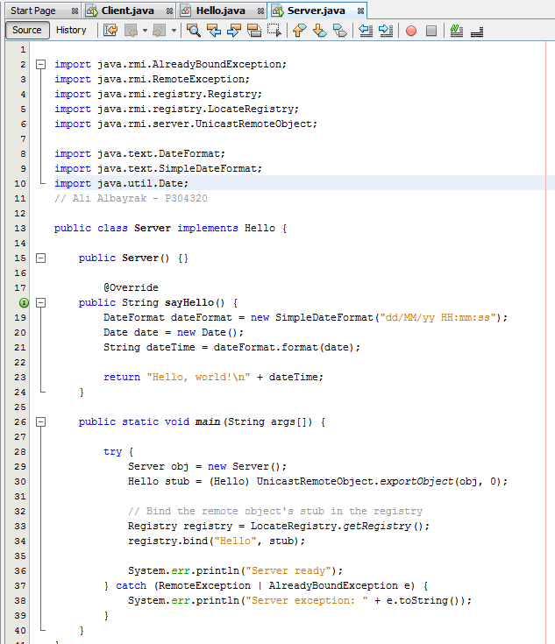

Client Side:

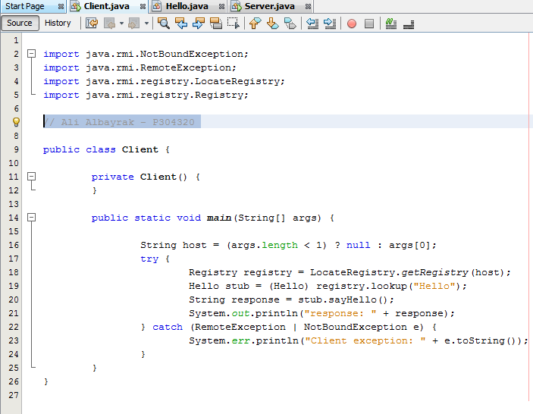

Hello.java(Remote Interface)

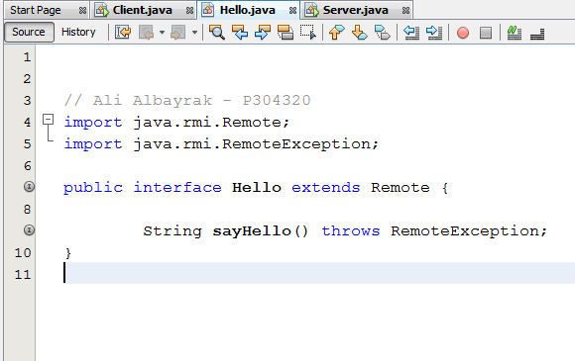

Output:

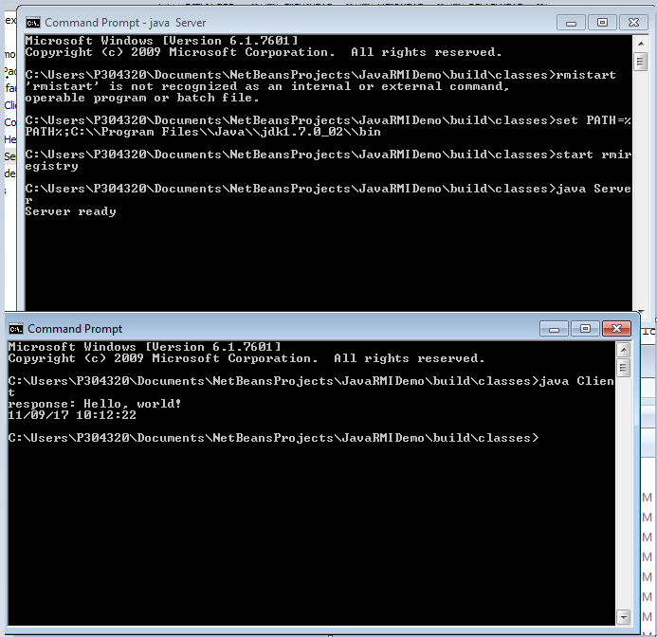

3. Demonstrate how to create program API document with JavaDoc utility. Provide sample classes and the document, in HTML format, created from the class source files.

We can use javadoc filename.java command on cmd.exe to create javadocs.

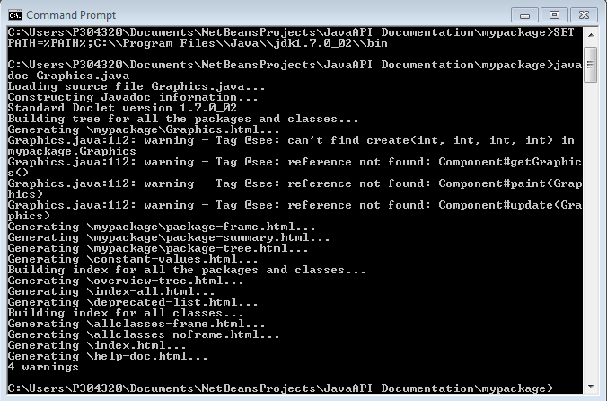

After Creating javadoc:

